FCSal Funding Update

Grant Recipient
Jose Luis Pérez-González - Fundación Atelopus (joseperezgonzalez2407@gmail.com)

Date Funding Awarded
28/02/2023

Date of Update
6/09/2023

Título del proyecto: | Ensuring the endemic salamander conservation (Bolitoglossa savagei) through community-based conservation actions in Sierra Nevada de Santa Marta (SNSM) Key Biodiversity Area, Colombia.
Principal Investigator (PI) name:  Job title:  Institution:  Address:  Phone:  Fax number:  Email address: | Jose Luis Pérez González  Principal Investigator  Fundación Atelopus  Street 50 #30-9 TORRE 4 APTO 501 Senderos Reservas de Curinca, Santa Marta, Colombia  (+57) 304 3998177  joseperezgonzalez2407@gmail.com
Amount of Grant Award: | $ 5000
Collaborator name:  Job title:  Institution:  Address:  Phone:  Fax number:  Email address: | Jose Daniel Barros Castañeda  Environmental Education Coordinator  Universidad del Magdalena  Street 5 #10-02 Bonda, Santa Marta, Colombia  (+57) 3232883650  josebarrosdc@unimagdalena.edu.co
Collaborator name:  Job title:  Institution:  Address:  Phone:  Fax number:  Email address: | Aldair Alberto Barros Granados  Communications Coordinator  Fundación Atelopus  Street 23#8-13 Centro, Santa Marta, Colombia  (+57) 3207521971  aldairbarrosg@gmail.com

Project description

Our project provides a unique case where we will use the only endemic and threatened species of salamander in the Sierra Nevada de Santa Marta (SNSM) to unite visions and promote effective actions and strategies for its conservation in conjunction with local communities. We will also provide relevant information to build the baseline population and epidemiological monitoring for the species, whose data will provide scientific tools for the construction of Colombia's national
amphibian plan, as well as data for the improvement and management of protected areas by environmental authorities.

Progress Report

To date, we have conducted two field trips, finding a total of 32 individuals, corresponding to 13 juveniles and 19 adults, and during the month of July the abundance of Bolitoglossa savagei was higher than in May (Fig 1). It has been observed that B. savagei is more abundant in native wooded areas and at a considerable distance from streams, probably avoiding the wind observed in these places. Preferring places such as bromeliads that can provide shelter from dehydration, as well as perching in shrubs and grasses. In the pine forest and pasture area, it is more difficult to find individuals due to the homogeneity and lack of variety of microhabitats used by the species. The smallest individual was a juvenile 38.54 mm weighing 1.12 gr and the largest 152.23 mm weighing 9.75 gr; this observation is very important for our population monitoring, because we found almost the entire life stage of the species (Appendix 1). In addition, we have performed 20 epidemiological samples of Bd, 10 per field trip, which are currently in the process of analysis.

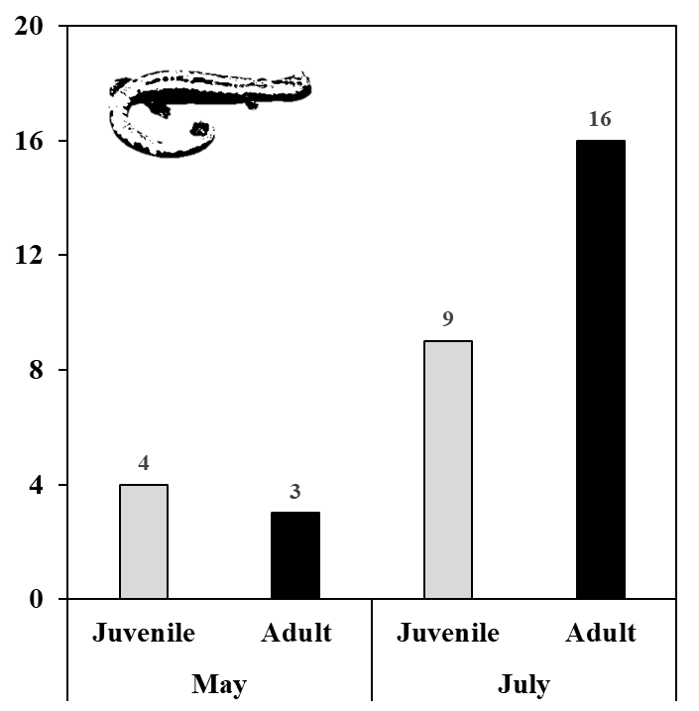
Figure 1. Abundance of juveniles and adults of B. savagei during the samplings carried out so far.

Celebration “Salamander Saturday” and Education workshops with communities

One of the objectives of us as an NGO is to involve local communities and make visible the problems of threatened endemic amphibians of the Sierra Nevada de Santa Marta. Therefore, taking into account the initiative by FCSal in the celebration of Salamander Saturday, we conducted our first educational workshop with 24 children from the community in the village of Minca, SNSM (Appendix 2). A space that allowed us to observe the children's perceptions about the mountain salamander, a playful talk was given about the generalities and importance of B. savagei in our environment. In addition, before the talk, a semi-structured survey was executed and the results were interesting, where 71% of the children have not observed the Salamander Serrana (Fig 2), but 67% know that the salamander is endemic to the SNSM (Fig 3), however, only 30% are aware that it is under threat. When asked questions about the environment, such as whether water was important for the salamander, 67% answered yes, unfortunately there is uncertainty as to whether this resource is of good quality or clean, 70% answered maybe and this is probably due to threats such as: poor waste management (54%), motorcycle washers (13%) or both of these activities (33%) (Fig 4). These responses provide us with a local perspective of the possible threats to B. savagei in its habitat.

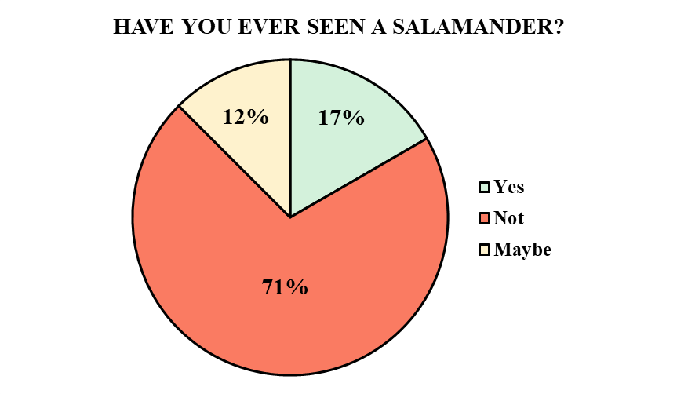
Figure 2. Introductory question about the presence of the Serrano Salamander in the locality.

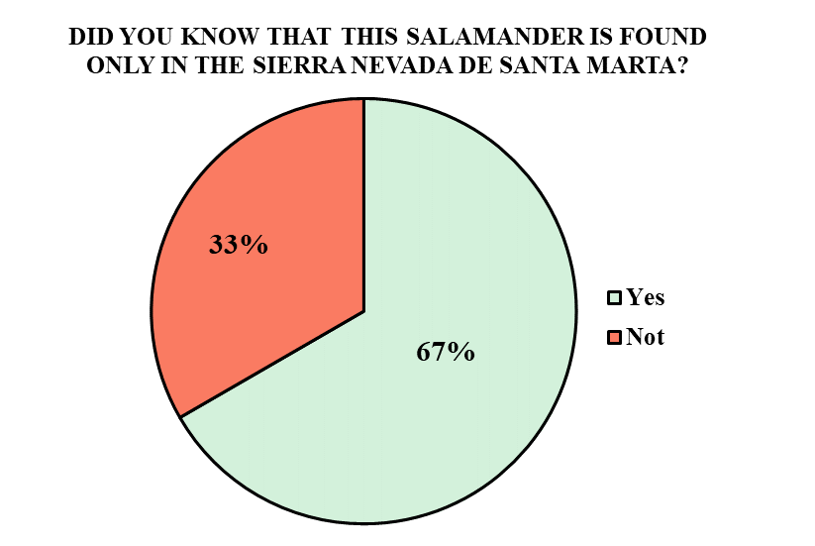
Figure 3. Question about the endangered status of the Saw-toothed Salamander.

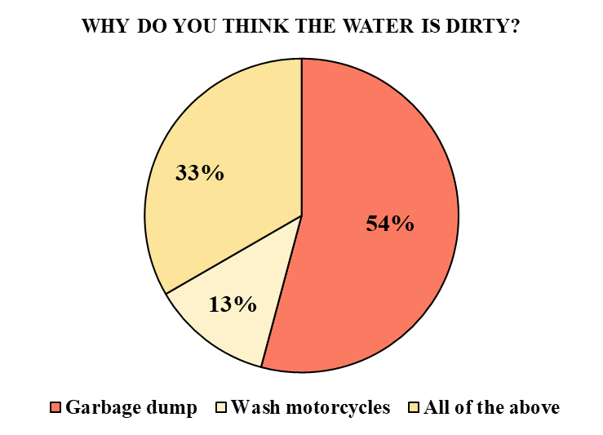
Figure 4. Question regarding water quality in the Minca sector, Sierra Nevada de Santa Marta.

Education workshops with local schools to raise awareness about the importance of protecting the habitat of Bolitoglossa savagei

Our second workshop was held with students of the Agroecological Educational Institution "Sagrado Corazón de Jesús" in the locality of Vista Nieve, Sierra Nevada de Santa Marta. In this opportunity, to make visible the presence of B. savagei for this locality, in addition to aspects related to its biology, the importance of water for its development and conservation of the native forest. The active participation of the local communities has been fundamental. Undoubtedly, they have benefited from multiple perspectives during the project because they have developed interest, commitment, sensitivity and empowerment towards biodiversity conservation in general. At the same time, they have also benefited from the community cohesion promoted through active participation in the development of strategies to promote sustainable development and improve the quality of life of their community (Appendix 3).

Budget allocation
Budget category | Item/Import | Amount spent | Remaining funds
Travel and local  transportation  (inluding fuel) | Gas, brake fluid and oil change for  car. Each rountrip to our sampling  sites needs on average 20 gallons  of gas | 100 | 100
Lodging/Food | Lodge for 3 team members for 2 sampling seasons (4 days each) / Three meals per day for 3 team members for 3 sampling seasons (4 days each) | 820 | 946
Workshops | workshops, refreshments and transportation in the local  school and  workshops with community  leaders | 450 | 480
Outreach/education  activities and  materials | Posters, brochures and education materials | 170 | 200
Scientific/ Field  equipment  and supplies | Waterproof field notebooks  Digital Pocket Scale PESOLA  Data Logger HOBO  2 Garmin Hand GPS eTrex Touch  Lamp Headlight Head  Ambidex Disposable Nitrile Gloves.  Powdered x 50 Pairs  Flagging Tape Plastic Fluorescent | 659 | 0
Equipment/Lab | Crioviales x 500 units  1.000 Swaps x 500 units  Analysis of the fungus (Bd) | 500 | 0
Boat/engine/truck  (include car hire) | auto insurance | 350 | 225
Total |  | 3049 | 1951

Next steps and future directions

The remaining field trips will continue, increasing the collection of data on the population dynamics of Bolitoglossa savagei. Similarly, the epidemiological analysis to determine the presence and prevalence of the fungus, these samples are currently in the process of analysis. In addition, the remaining threat mapping workshops and land use mapping, including the different coverages in the habitat of this endangered salamander.

Appendix 1

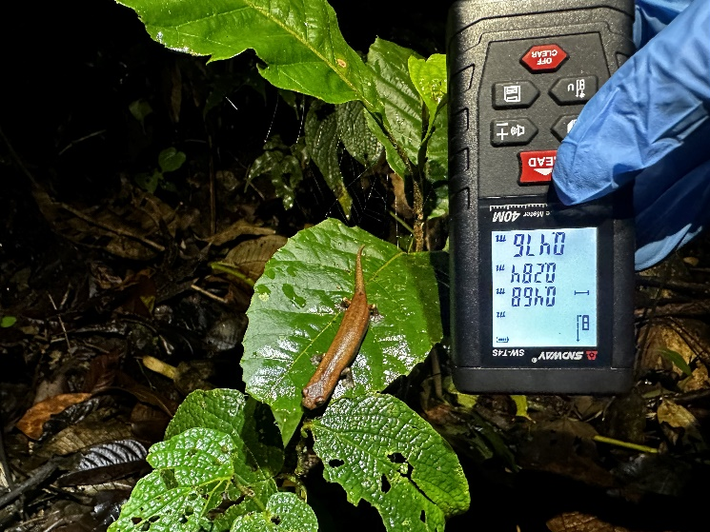
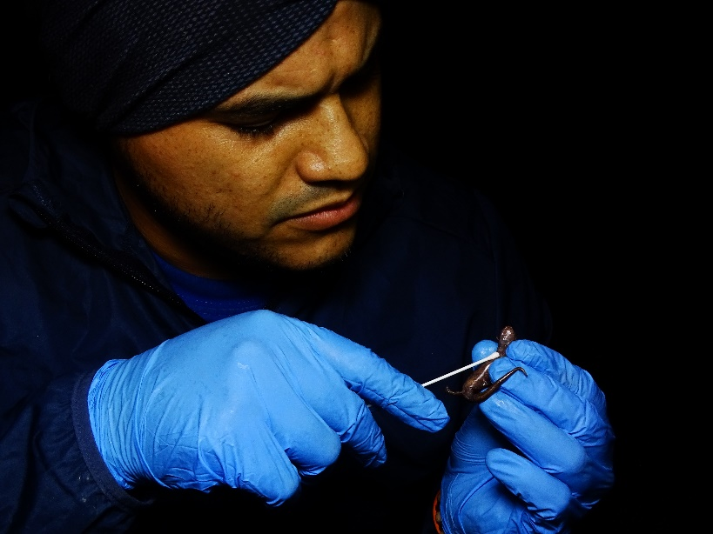
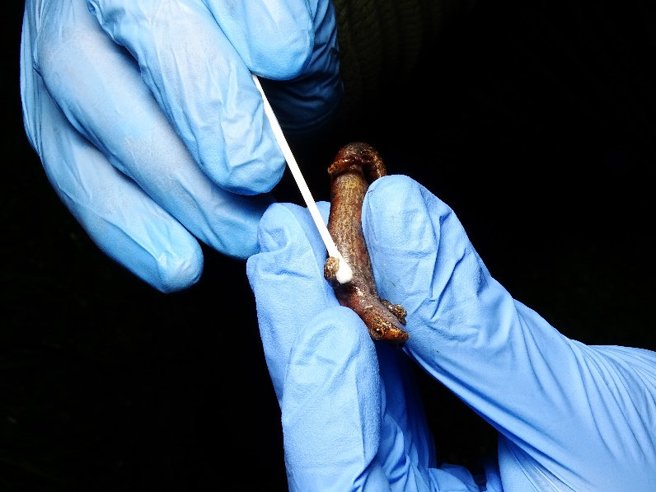
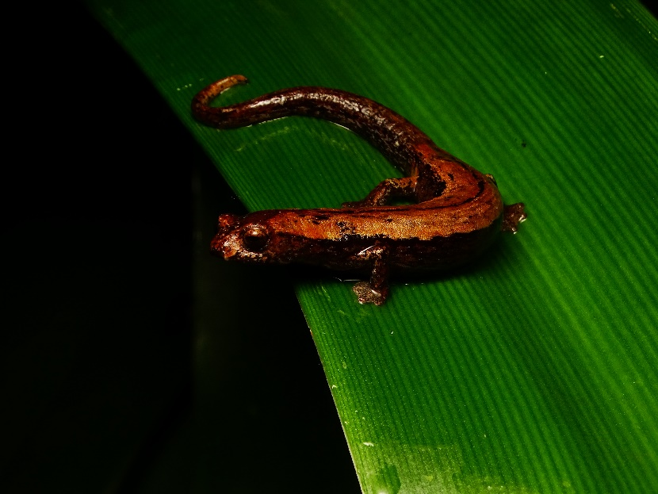
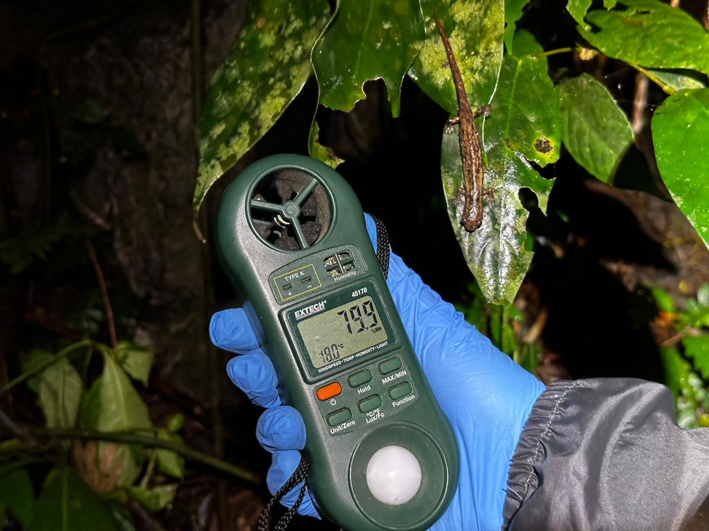

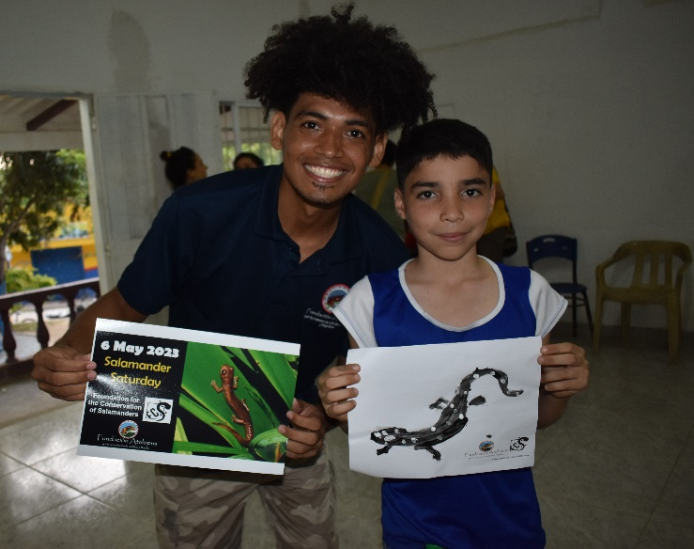
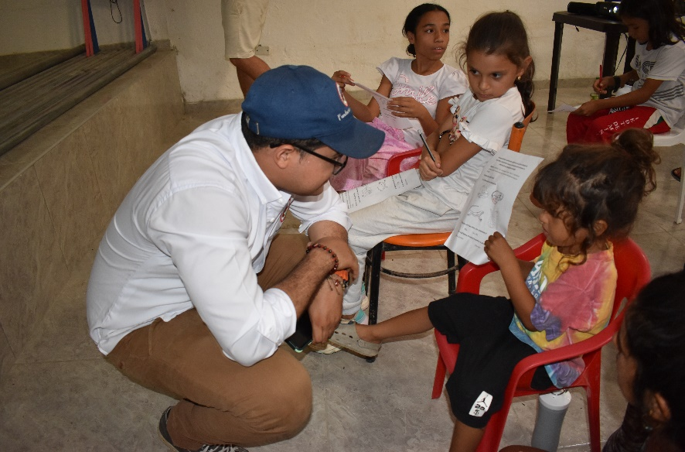
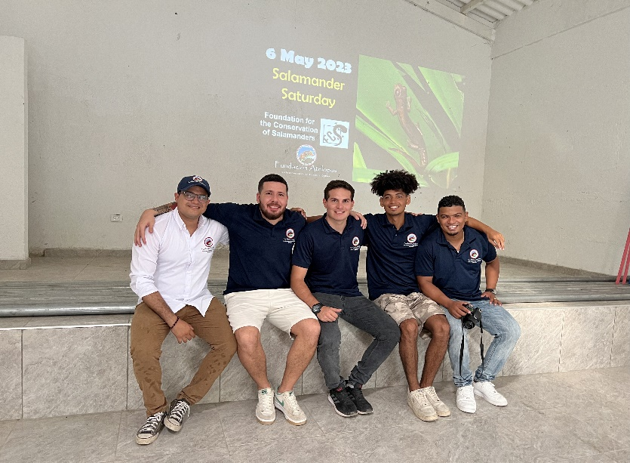
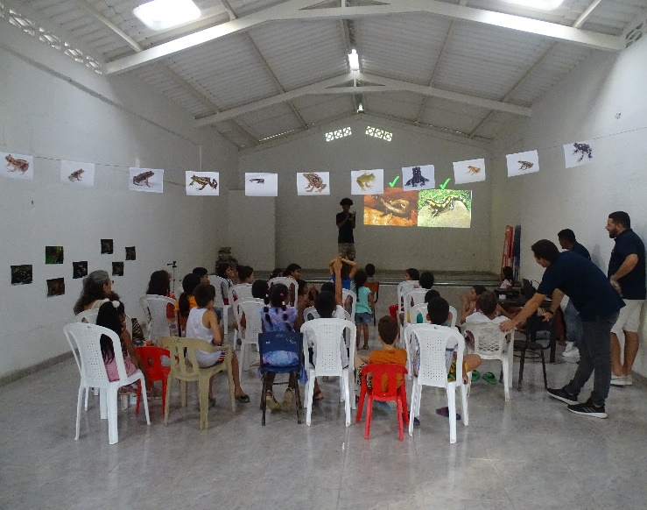
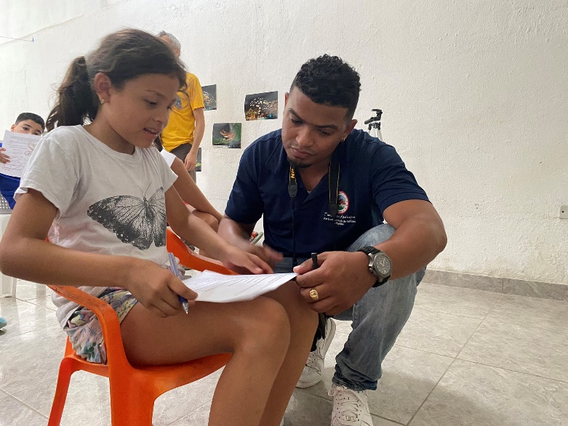
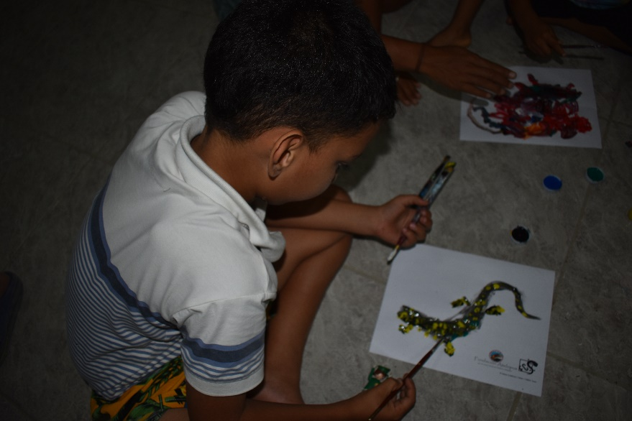
Appendix 2

Appendix 3

