#### FCSal Funding Update

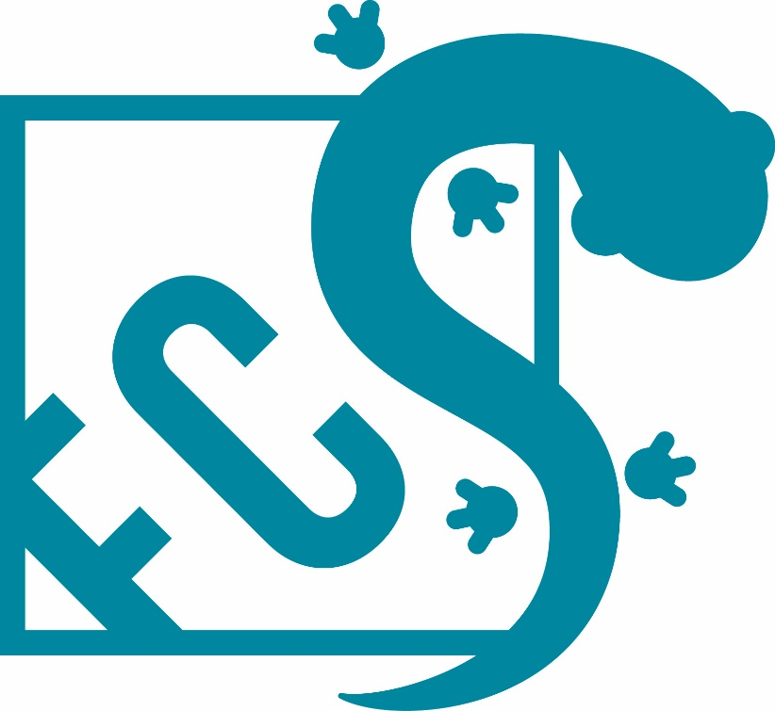

**Grant Recipient**

**Molly Bletz, University of Massachusetts (molly.bletz@gmail.com)**

**Date Funding Awarded**

**2018**

**Date of Update**

**4/8/2023**

**Photos**

*Please insert a few pictures of your project here, or include them as attachments when you submit this report via email. Pictures of researchers, salamanders, and/or study site are best.*

|  |  |
| --- | --- |
| Project Title: | Proactive development of mitigation tactics to combat the salamander-eating fungus |
| Principal Investigator (PI) name:  Job title:  Institution:  Address:  Phone:  Fax number:  Email address: | Molly Bletz  Postdoctoral Research Associate  University of Massachusetts  100 Morrissey Blvd. Boston, MA 02125  (617)-505-8165  NA  Molly.bletz@gmail.com |
| Amount of Grant Award: | 5,000 |
| Collaborator name:  Job title:  Institution:  Address:  Phone:  Fax number:  Email address: | Douglas Woodhams  Assistant Professor  University of Massachusetts Boston  100 Morrissey Blvd. Boston, MA 02125  (617)-287-6679  NA  douglas.woodhams@umb.edu |
| Collaborator name:  Job title:  Institution:  Address:  Phone:  Fax number:  Email address: | Reid Harris  Co-leader of Bsal Task Force Technical Advisory  Committee  Director of International Disease Mitigation – Amphibian  Survival Alliance  (540)-421-3472  harrisrn@gmail.com |
| Collaborator name:  Job title:  Institution:  Address:  Phone:  Fax number:  Email address: |  |

**Project Description**

**Project Partners:** We are partnering with the Bsal Task Force, an international group focused on research, management, and policy implications of Bsal. The Research Working Group of the Task Force will help guide sampling and experimental design to ensure effective integration into Bsal-related research initiatives. Priya Nanjappa, National PARC Coordinator and Program Manager for Association of Fish and Wildlife Agencies will also serve as an unofficial partner as she currently serves as my practitioner mentor for my David H. Smith Conservation Fellowship. Her network and expertise will help coordinate with state wildlife agencies and translate our results into action.

**Background:** The Appalachian woodlands are home to a vast diversity of salamanders. They don’t hop or croak but silently wander through the leaf litter and dart about forest streams providing important ecosystem functions. The two selected target species, Blue Ridge Two-lined salamander (*Eurycea wilderae*) and Northern Two-lined salamander (*Eurycea bislineata*), inhabit streams and their riparian habitat, and are highly susceptible to Bsal (Matt Gray unpub. data). Therefore, developing conservation strategies that enable salamander persistence within forests is crucial. Our objective is to develop effective tools for combatting Bsal by testing field-viable disease mitigation tactics. The central goal of disease mitigation is increasing the proportion of protected individuals within a population enabling population persistence within a Bsal-positive habitat. We can target aspects of the hosts’ defenses or environmental factors to develop mitigation strategies. Addition of locally-occurring protective bacteria to amphibian skin has effectively prevented Bd-associated chytridiomycosis in laboratory trials and a field trail (4–8). Probiotic bioaugmentation aims to increase anti-fungal function of the skin mucus so

infection is avoided or reduced, and can be implemented through individual probiotic baths (5) or

environmental treatment (7). Vaccination can boost a host’s adaptive immunity. An unexplored area for

amphibians is mucosal vaccination, a promising approach to stimulate vertebrates’ mucosal defense (9).

Recently, research demonstrated that nasopharynx-associated lymphoid tissue (NALT) is a first line of

defense against waterborne antigens in fish (10) and tadpoles (11, 12). Nasal delivery of vaccines against

bacterial and viral diseases showed promising results in rainbow trout (13), and may be effective for treating salamanders. Aquatic micropredators affect Bd infection risk (14). Certain microeukaryotes (e.g.

Notommatidae family, Paramecium spp. and Daphnia ) can consume fungal zoospores, reducing infection

probability and intensity (14–17). Thus, manipulation of micropredator communities could be a feasible

tactic. For stream-dwelling salamanders host treatments may be ideal due to stream flow. Importantly,

potential non-target effects of probiotics or micropredators on ecosystems must be evaluated before moving towards field-based application.

**Specific Activities and Methodology:**

To accomplish our objective three activities are necessary.

(1). Sample salamander skin bacteria at three locations for each target species. Culture and test resident skin. microbes isolated from collected samples for their ability to inhibit Bsal growth.

(2). Sample and characterize aquatic micropredator communities at all sites. Test Bsal-consuming abilities of collected communities and selected taxa found in these communities.

(3). Perform two experiments to test effectiveness of vaccination, skin probiotic bioaugmentation, and environmental micropredator augmentation in reducing Bsal infection and lethal disease.

**Progress Report to Date**

In March 2018, sampling of *Eurycea wilderae* occurred at four locations in North Carolina (Table 1). We collected skin swabs for culturing bacteria and water samples for characterizing the micropredators in the stream environments. During this field work I met with one of North Carolina’s state wildlife biologists to establish a collaboration that will allow us to receive 40 individual *E. wilderae* in September for testing of disease mitigation strategies. In August of 2018 sampling of *E. bislineata* occurred at one location in Massachusetts. In summer 2018 work began to culture skin bacteria from the collected samples.

A picture containing indoor, cup, sitting

**Table 1**. Sample size of *Eurycea* salamanders at site in North Carolina and Massachusetts.

|  |  |
| --- | --- |
| Location | Number of Individuals |
| Harmon Den (NC) | 2 |
| Wolf Branch (NC) | 9 |
| Pink Beds (NC) | 10 |
| App. state stream (NC) | 10 |
| Minns Sanctuary (MA) | 10 |

By the end of the summer, we successfully cultured 32 skin bacteria isolates from our samples collected in March from *Eurycea wilderae*. We tested these isolates for their ability to inhibit *Bsal* is still underway and Two isolates were found, to strongly inhibit *Bsal* growth in VOC-assay, which means they are able to inhibit the deadly salamander fungus without contact (Figure 1).

Thanks to Lori Williams and her team at North Carolina’s Wildlife Resource Commission we now have 30 *Eurycea wilderae* in the lab for performing disease mitigation trials. These stream salamanders can be hard to find, but Lori and her team are salamander whisperers! We received these salamanders and in September and kept them happy and healthy in our animal care facilities until we are ready for probiotic trials.

**Figure 1**. VOC split plate assay showing a complete inhibition of Bsal growth without contact.

We were also able to characterize the microbial community of the wild sampled *Eurycea wilderae* (Figure 2). Salamanders form different sites exhibited different microbial communities. In particular, the site in Boone near Appalachian State University was distinct from the two southern sites in Pisgah National Forest (Pink Beds & Wolf Branch). All communities had high proportions of Pseudomonadaceae; while the Pisgah sites had high proportions of Xanthomonadaceae and Brucellaceae, the Appalachian State site had higher amounts of Sanguibacteraceae. Pseudomonadacaeae and Xanthamonadaceae are groups known to have many fungal inhibiting members.



**Figure 2**. Microbial community composition of Eurycea wilderae at three locations in North Carolina. Inset image on the left shows the locations of sampling sites and the colors link to the color codes on the taxonomy plots on the right. The top 5 bacterial families are noted in the legend in the lower left.

In 2021, a disease mitigation experiment focusing on probiotics was completed with *Eurycea* *wilderae*. We focused on this tactic as a first step and due to reduced numbers of individuals being available for the trial.

Briefly, we had two treatment groups: Bsal controls (exposed to Bsal only) and a Probiotic treatment group (treated with probiotics prior to exposure to Bsal). Probiotic treatment was administered via a 2-hour bath in artificial pond water containing the probiotic bacteria (*Pseudomonas poae*). A week after treatment, all individuals were exposed to Bsal zoospores) and monitored and swabbed thereafter for 14 weeks.

Figure . Survival probability of Eurycea in the disease mitigation experiment. Control group is represented in red and probiotic-treated group is represented in blue

Survival was significantly greater in the probiotically-treated group compared to the controls (Figure 3) demonstrating that the addition of inhibitory bacteria conferred protection against the fungal pathogen Bsal.

A picture containing indoor, food


Figure . Eurycea in its housing enclosure

**Budget Allocation**

|  |  |  |  |
| --- | --- | --- | --- |
| **Budget Category** | **Item/Amount** | **Amount spent** | **Monies remaining** |
| Lab Supplies (Act.1) | 1752 | 2152 | 0 |
| Lab Supplies (Act.2) | 840 | 0 | 0 |
| Experiment Supplies (Act. 3) | 2408 | 2848 | 0 |

**Next Steps and Future Directions**

Bsal emergence significantly threatens salamander diversity. Effective conservation requires practical, implementable tools. The proposed research cultured skin bacteria from one of the most Bsal-threatened US salamander species and shown that **one promising options for mitigating Bsal-associated chytridiomycosis, skin probiotic bioaugmentation was successful at reducing Bsal-associated mortality in these threatened stream salamanders**.

While this work was conducted in a laboratory setting, future work can test these strategies in more semi-natural conditions such as stream mesocoms to future understand how we can enable species and populations to persist within natural habitats. Our proposed work included characterizing the micropredator populations of stream habitats and testing the zoospore consuming behavior of the identified groups. While we did collect samples from natural streams and identify Gammarus species as one of the most common members, we put continued work with this research direction on hold for two reasons: (i) use of micropredator as a management strategy is stream settings may be challenging given the constant and variable flow, and (ii) with the number of salamanders available for experimental testing, focusing on one disease mitigation tactic made the most sense. Our work also can inform conservation for other wildlife disease threats, such as White-nose Syndrome, Snake Fungal Disease, or Bd-associated chytridiomycosis. Currently, we have an opportunity rare to conservation science: the opportunity to be proactive and provide tools to avert the reality of salamander silence. This work as made strides in this area identifying probiotic bioaugmentation as a possible strategy that can be implemented by managers proactively to combat the salamander-eating fungus.