FCSal Funding Update



Grant Recipient
Chace Holzheuser, Florida State University (ch18dc@my.fsu.edu)

Date Funding Awarded
02/18/2020

Date of Update
02/16/2022

Table of Contents

 | Page #
Project and PI details | 3
Project Description | 4
Progress Report | 4
Budget allocation to date | 5
Next Steps and Future Directions | 6

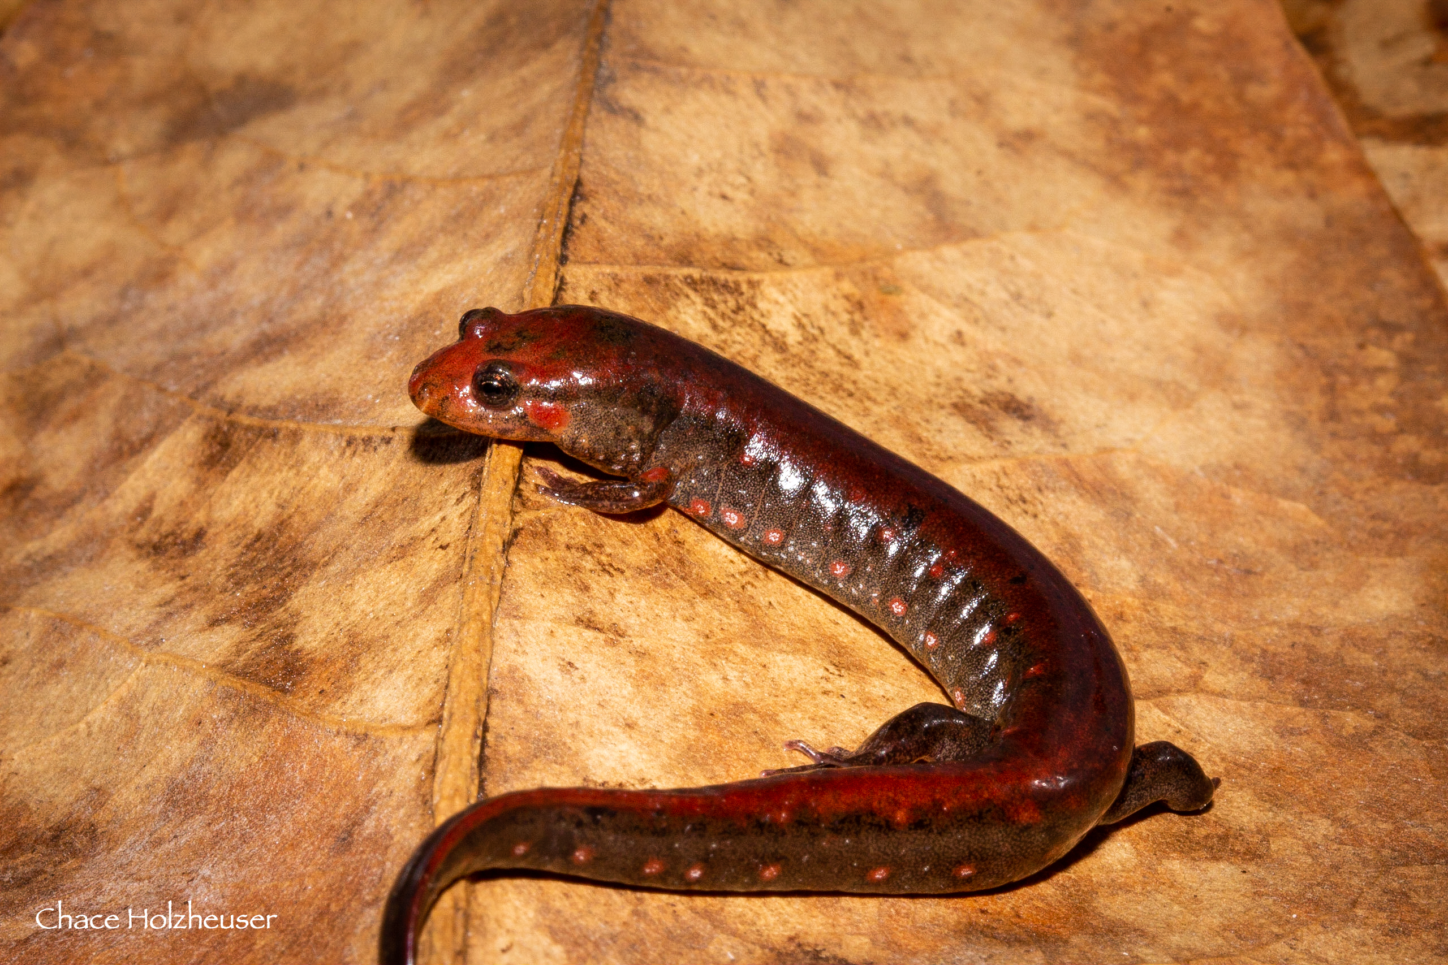

Southern Dusky Salamander! Photo credit: Chace Holzheuser

Project Title: | Population Genetics of the Southern Dusky Salamander
Principal Investigator (PI) name:  Job title:  Institution:  Address:  Phone:  Fax number:  Email address: | Chace Holzheuser  Graduate Student  Florida State University  2129 Longview Dr., Tallahassee, FL 32303  (979) 204-4088  c.holzheuser@gmail.com
Amount of Grant Award: | $1,500
Collaborator name:
Job title:
Institution:
Address:
Phone:
Fax number:
Email address:
Collaborator name:
Job title:
Institution:
Address:
Phone:
Fax number:
Email address:
Collaborator name:
Job title:
Institution:
Address:
Phone:
Fax number:
Email address:

Project Description

The southern dusky salamander (Desmognathus auriculatus, SDS) has experienced range-wide declines. From 2016 to 2019 I spent 461 hours searching 256 sites where the salamander was previously known and found it at only 20 sites. My data, combined with other research, suggests the southern dusky salamander is restricted to five fragmented pockets in Florida and Georgia. This striking decline led me to conduct a population genetic survey of all remaining populations so that I may inform the US Fish and Wildlife Service and other conservationists of the salamander’s current health. Understanding an imperiled species’ population genetics is vital to the success of recovery efforts by identifying important characteristics of their demographics such as effective population size, genetic structure, and patterns of dispersal. Given the large genome of Desmognathus salamanders, I will use next-gen sequencing to sample their genetics. I plan to collect at least 15 tissue samples from 17 sites of known SDS presence and sequence the tissue using novel population genetics techniques on an Illumina HiSeq2000 at the Florida State University College of Medicine. I will assess genetic patterns using programs such as STRUCTURE and MIGRATE to quantify pairwise and global F_{st}, Wright’s fixation index (F_{IS}), observed heterozygosity, expected heterozygosity, and gene flow estimates to determine the number and distribution of discrete populations, population structure at short distances, effective population size, past population bottlenecks, and patterns of dispersal. My goal is to provide the USFWS with a detailed analysis of the SDS conservation status.

Progress report to date
I have finished the field work portion of this project and collected tissue samples from 255 individuals at 17 sites (Table 1). Originally, I planned to collect samples from only 15 sites, but 2 new populations of D. auriculatus were discovered in Georgia during this project. One of the sites was on a military reservation which, until recently, was closed to public access during COVID-19 restrictions. However, I collaborated with partners in Georgia to acquire the additional samples. I have now collected samples from every known population of Southern Dusky Salamanders, which will provide a complete analysis of the species’ status.
COVID-19 social distancing restrictions have severely limited my ability to conduct lab work, but my lab mates and I are working around each other’s schedules. So far, I’ve conducted a preliminary genetic analysis of tissue samples from 8 individuals from 4 sites. I extracted the DNA using a DNeasy Blood and Tissue Kit and prepped them for sequencing using a new PopGen technique developed in the Lemmon Lab at FSU (Methods paper in preparation). We performed high-throughput sequencing using the Illumina HiSeq2000, College of Medicine, Florida State University. Sequencing revealed several thousand SNPs and potential microsatellites. I am currently optimizing the technique to increase the number of sequenced loci for more accurate PopGen analysis.

Table 1— Location of field sites where I have collected Southern dusky salamander tissue.
Latitude | Longitude | Site | No. Collected | No. Remaining
30.29 | -84.58 | Apalachicola NF, Site 1, FL | 15 | 0
30.13 | -84.51 | Apalachicola NF, Site 2, FL | 15 | 0
30.14 | -84.60 | Apalachicola NF, Site 3, FL | 15 | 0
30.27 | -84.89 | Apalachicola NF, Site 4, FL | 15 | 0
30.21 | -84.91 | Apalachicola NF, Site 5, FL | 15 | 0
30.23 | -84.47 | Apalachicola NF, Site 6, FL | 15 | 0
30.32 | -84.49 | Apalachicola NF, Site 7, FL | 15 | 0
31.88 | -81.76 | Ft. Stewart, GA | 15 | 0
30.15 | -84.53 | Apalachicola NF, Site 8, FL | 15 | 0
30.18 | -84.77 | Apalachicola NF, Site 9, FL | 15 | 0
30.20 | -82.41 | Osceola NF, FL | 15 | 0
30.80 | -81.93 | St. Mary’s River, FL | 15 | 0
30.13 | -84.48 | Apalachicola NF, Site 10, FL | 15 | 0
31.03 | -82.88 | Suwannoochee Cr., GA | 15 | 0
30.25 | -84.62 | Apalachicola NF, Site 11, FL | 15 | 0
31.50 | -81.91 | Penholoway Cr., GA | 15 | 0
30.02 | -84.44 | St. Marks NWR, FL | 15 | 0
 |  | Total: | 255 | 0

Budget allocation

Budget Category | Item/Amount | Amount spent | Monies remaining
Field Work | Collection Tubes and EtOH | $125 | $0
Field Work | Travel (Fuel: 360miles x $0.44/gal; Lodging: $162) | $434.80 | $0
Lab Work | Reagents | $350 | $0
Lab Work | Oligos | $575 | $15.20

Next Steps and Future Directions
COVID-19 Travel and social distancing restrictions at Florida State severely impacted my, and my teammates ability to conduct lab work. Nevertheless, we have made great progress and are continuing to optimize the custom lab protocol for D. auriculatus. Our current task is to optimize the PopGen lab preparation for increased loci sequencing. The main challenge of conducting PopGen studies on salamanders is their incredibly large genome. Thus, although I have several thousand SNPs, I would like to increase the number of loci to estimate their population status more accurately.
Separate, but related, to this project, I’ve also completed a large-scale field survey for the species and submitted my findings in a state report to Florida Fish and Wildlife. Over the next few weeks, I’ll be converting the state report for peer-reviewed publication. I will use those publications, along with this PopGen study, to inform the US Fish and Wildlife Service of the conservation status of the Southern Dusky Salamander. Given my results, I believe the species easily qualifies for Endangered Status. This PopGen study will inform state and federal agencies how best to manage remaining populations of this imperiled salamander.

Please submit 2-4 photos with your update. Thank you

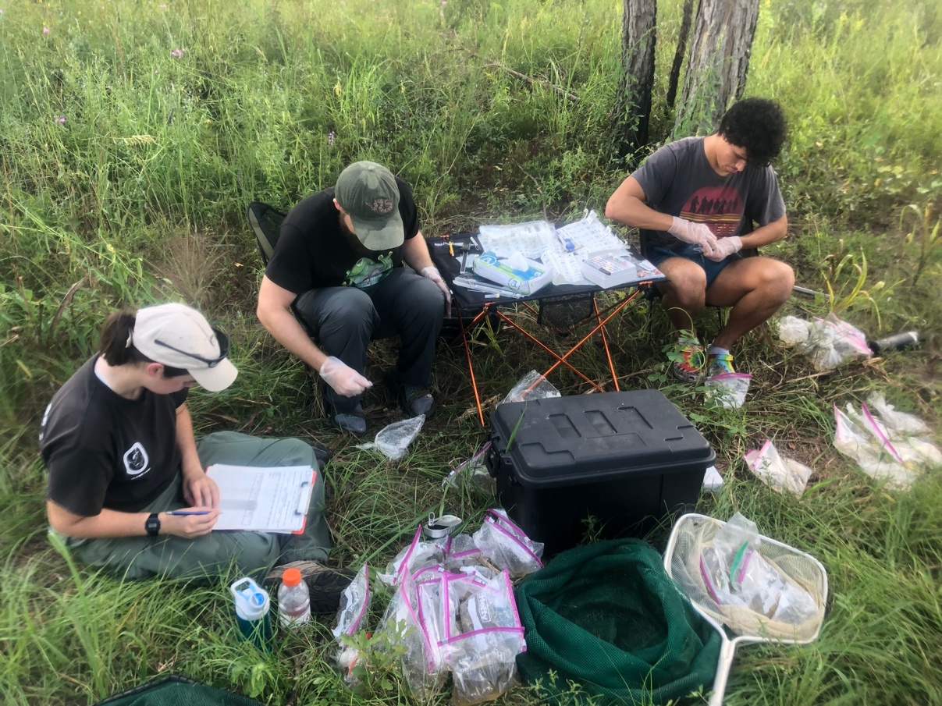
Description: Me and partners from Florida Fish and Wildlife, and the University of Florida swab salamanders caught in the field for pathogens. Photo credit: Chace Holzheuser

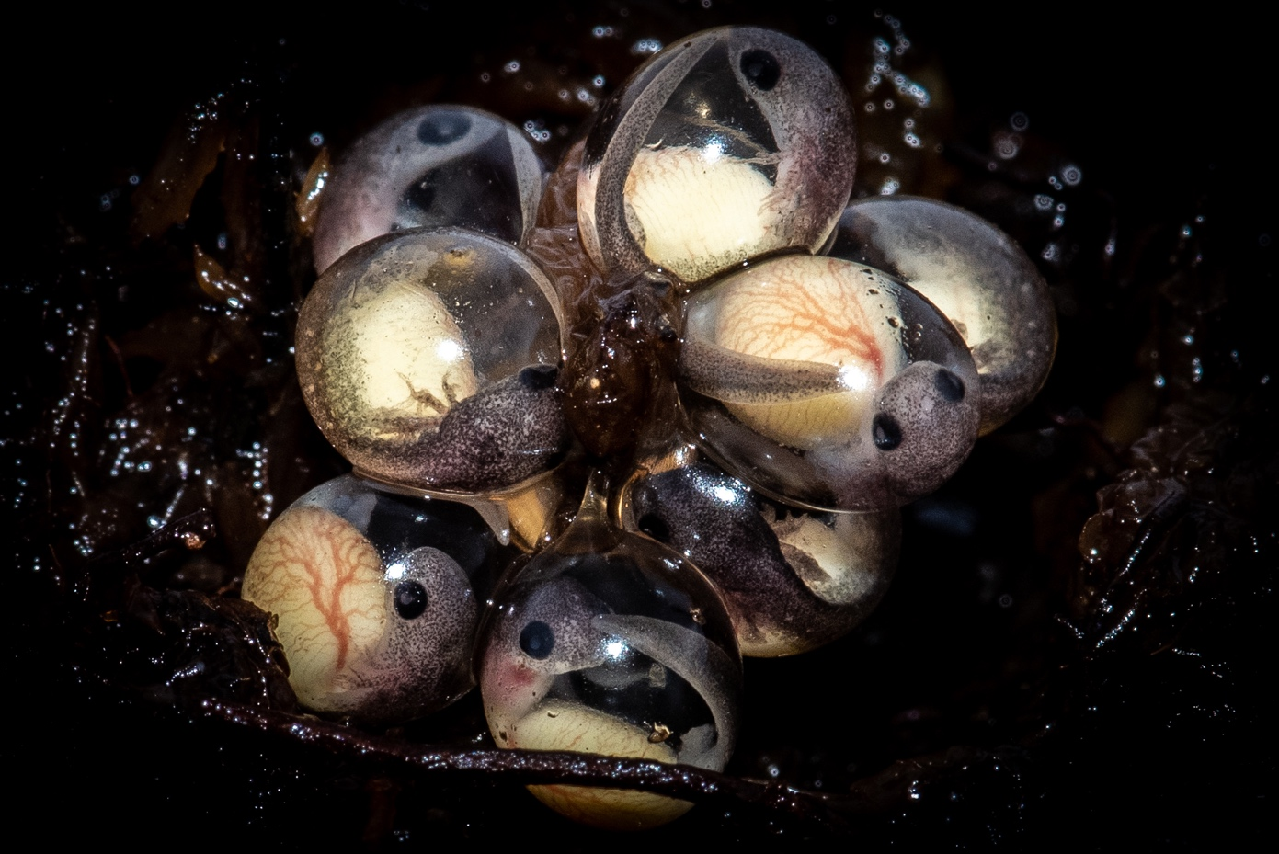
Description: While searching for adult Southern Dusky Salamanders on St. Marks NWR, I uncovered a clutch of species’ developing eggs. The mother was wrapped around them, but quickly escaped down a small hole next to the eggs. Photo Credit: Chace Holzheuser
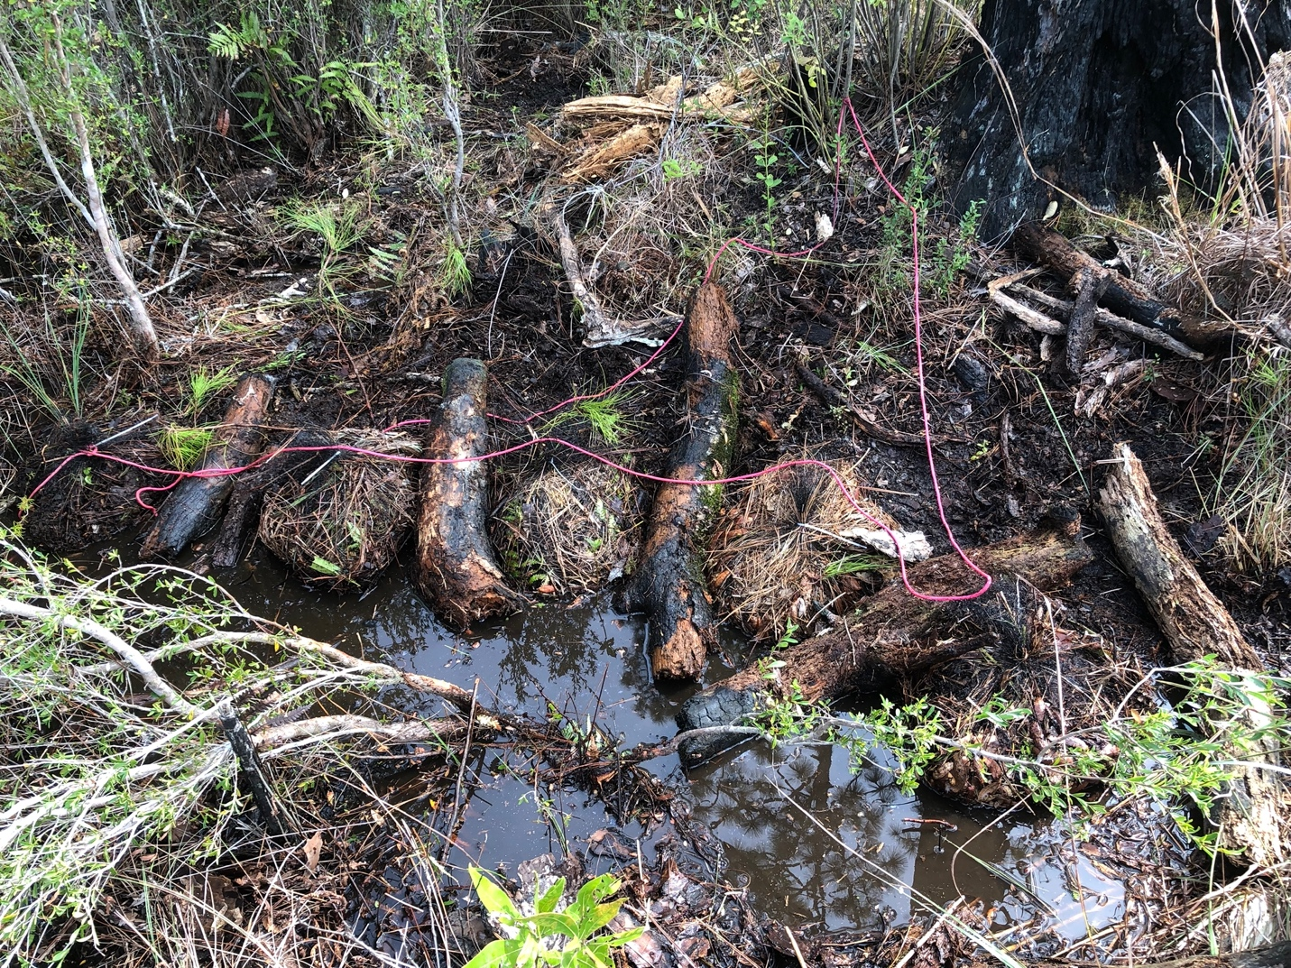
Description: Declining salamanders that are typically cryptic are tough to find! To increase my success in capturing them, I use a variety of techniques including litterbags and intentionally placed logs. Photo Credit: Chace Holzheuser

