FCSal Funding Update

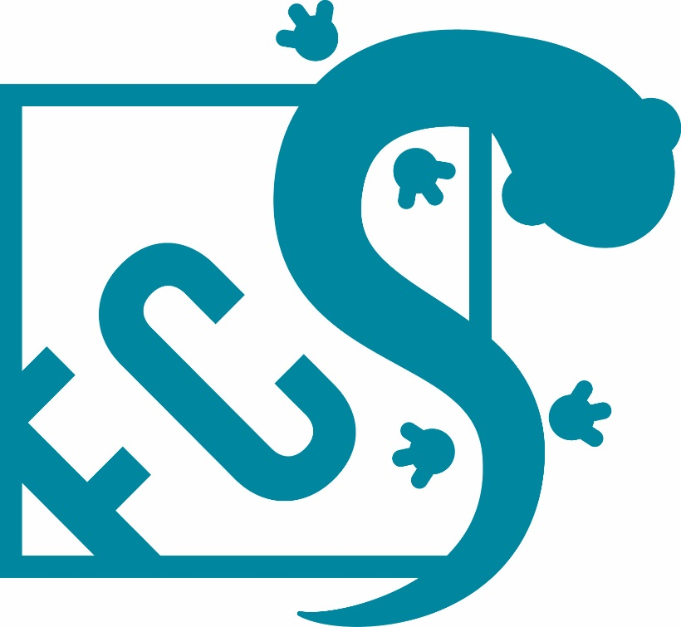

Grant Recipient
Chace Holzheuser, Florida State University (ch18dc@my.fsu.edu)

Date Funding Awarded
02/18/2020

Date of Update
01/12/2021

Table of Contents

 | Page #
Project and PI details | 2
Project Description | 3
Progress Report | 3
Budget allocation to date | 4
Next Steps and Future Directions | 4

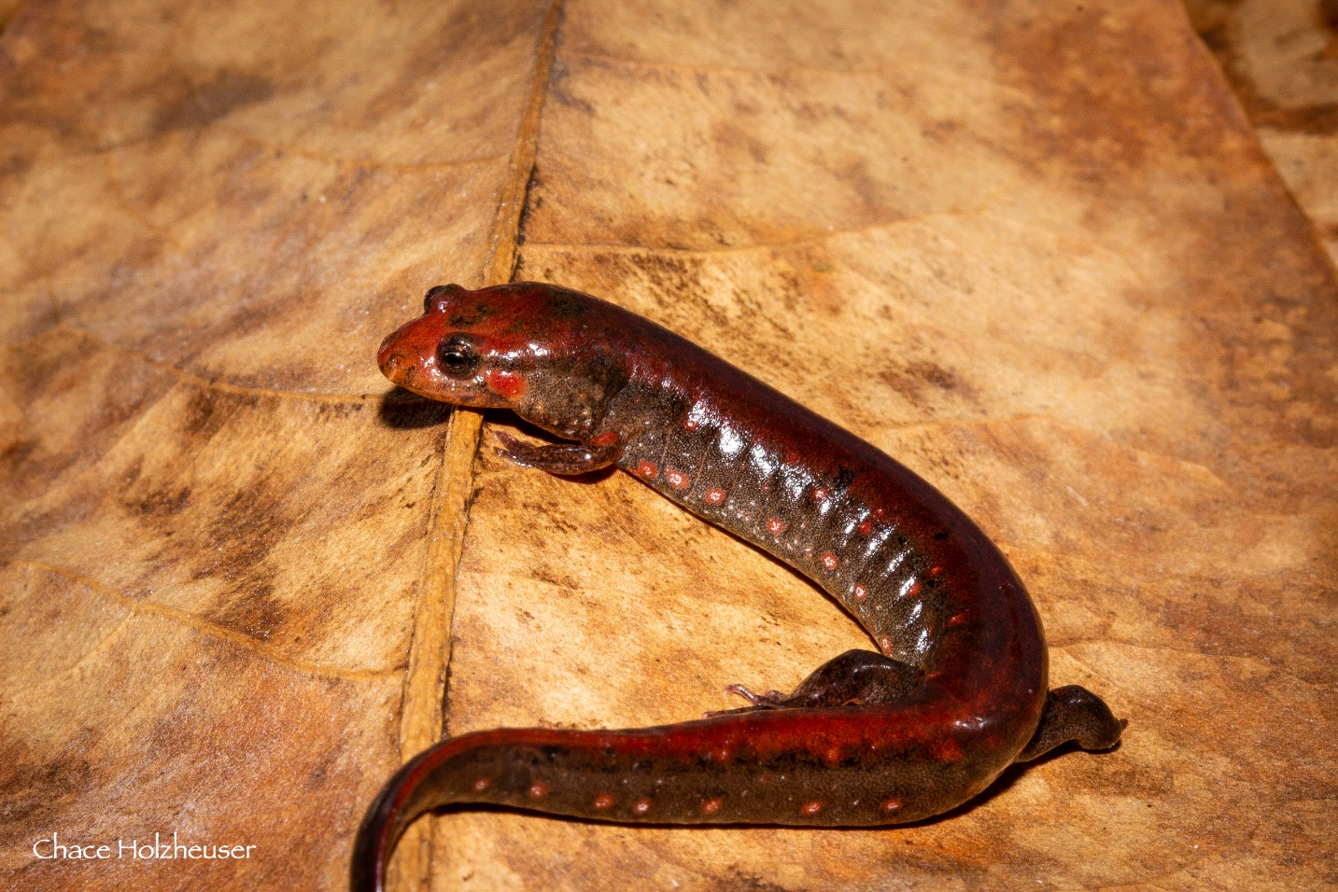

Southern Dusky Salamander! Photo credit: Chace Holzheuser

Project Title: | Population Genetics of the Southern Dusky Salamander
Principal Investigator (PI) name:  Job title:  Institution:  Address:  Phone:  Fax number:  Email address: | Chace Holzheuser  Graduate Student  Florida State University  2129 Longview Dr., Tallahassee, FL 32303  (979) 204-4088  c.holzheuser@gmail.com
Amount of Grant Award: | $1,500
Collaborator name:
Job title:
Institution:
Address:
Phone:
Fax number:
Email address:
Collaborator name:
Job title:
Institution:
Address:
Phone:
Fax number:
Email address:
Collaborator name:
Job title:
Institution:
Address:
Phone:
Fax number:
Email address:

Project Description

The southern dusky salamander (Desmognathus auriculatus, SDS) has experienced range-wide declines. From 2016 to 2019 I spent 461 hours searching 256 sites where the salamander was previously known and found it at only 20 sites. My data, combined with other research, suggests the southern dusky salamander is restricted to five fragmented pockets in Florida and Georgia. This striking decline led me to conduct a population genetic survey of all remaining populations so that I may inform the US Fish and Wildlife Service and other conservationists of the salamander’s current health. Understanding an imperiled species’ population genetics is vital to the success of recovery efforts by identifying important characteristics of their demographics such as effective population size, genetic structure and patterns of dispersal. Given the large genome of Desmognathus salamanders, I will use double-digest restriction-site associated DNA sequencing (ddRAD) to sample their genetics. I plan to collect at least 15 tissue samples from 17 sites of known SDS presence and analyze the samples using ddRAD, sequenced on an Illumina HiSeq 2500 at the Florida State University College of Medicine. I will assess genetic patterns using programs such as STRUCTURE¹⁵ and MIGRATE¹⁶ to quantify pairwise and global F_{st}, Wright’s fixation index (F_{IS}), observed heterozygosity, expected heterozygosity, and gene flow estimates to determine the number and distribution of discrete populations, population structure at short distances, effective population size, past population bottlenecks, and patterns of dispersal. My goal is to provide the USFWS with a detailed analysis of the SDS conservation status.

Progress report to date

Given their reduced population densities, Southern Dusky Salamanders are difficult to find, however I have collected 148 of the proposed 255 tissue samples from 15 of the 17 sites. I collected samples in Apalachicola National Forest, Osceola National Forest, and Ralph Simmons State Forest by sifting leaf litter and flipping logs along swampy margins of creeks, ponds and swamps. Once encountered, I captured the individuals, marked their exact point of capture with GPS, swabbed them for pathogen testing and stored a tail clip in 95% EtOH. I returned all amphibians to the place of capture, replaced cover objects to reduce impact on the populations, and stored the tissue samples in a -80C freezer in the lab. I have 107 remaining samples to collect from 10 sites in Florida and Georgia.

Budget allocation

Budget Category | Item/Amount | Amount spent | Monies remaining
Field Work | Collection Tubes and EtOH | $125 | $0
Field Work | Travel (Fuel) (360miles x $0.44/gal | $272.80 | $22.20
Lab Work | Reagents | $0 | $1,162.80
Lab Work | Oligos

Next Steps and Future Directions
COVID-19 Travel and social distancing restrictions at Florida State have severely impacted my ability to conduct fieldwork since all of it is outside the county. However, I anticipate collecting the remaining 107 tissue samples by May 2021 with help from local biologists in Georgia. Towards the end of January, I will begin extracting and sequencing the samples I have already collected and should be completely finished with the project by the end of summer 2021.

Please submit 2-4 photos with your update. Thank you!
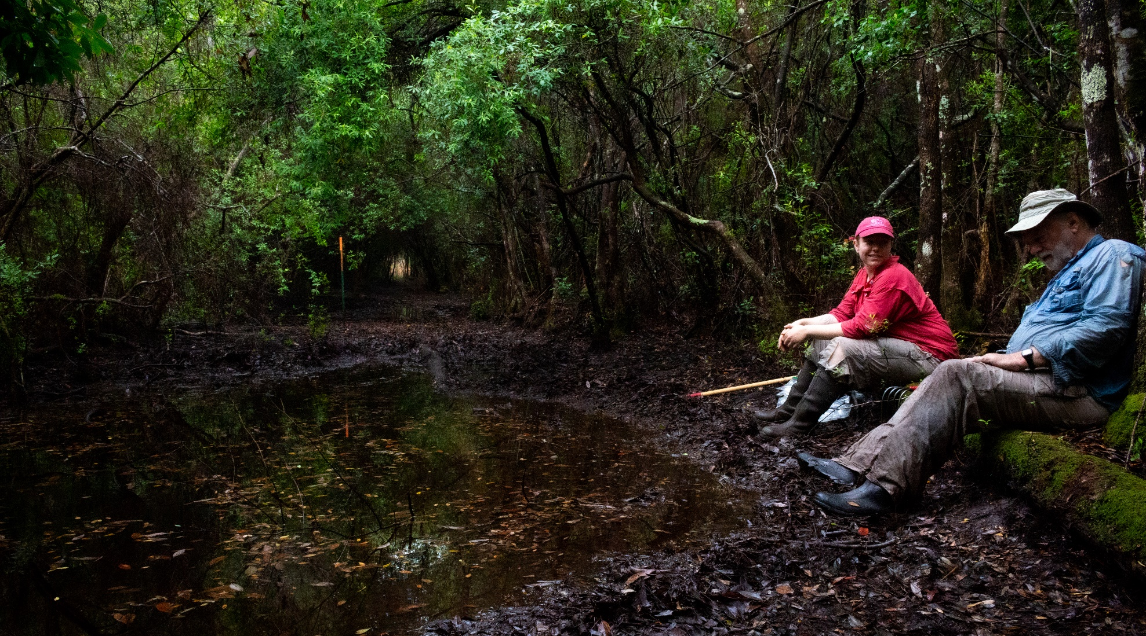
Description: Dr. Bruce Means and Dr. Jennifer Lamb in Apalachicola National Forest assisting me with catching Southern Dusky Salamanders. Photo by Chace Holzheuser

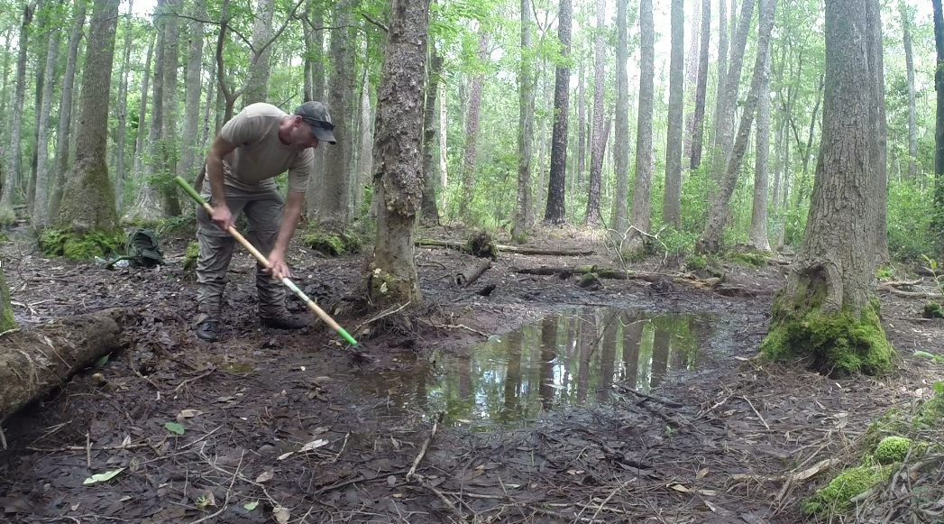
Description: Me scraping leaf litter around a swampy pool in Apalachicola National Forest to catch salamanders. Photo by Chace Holzheuser

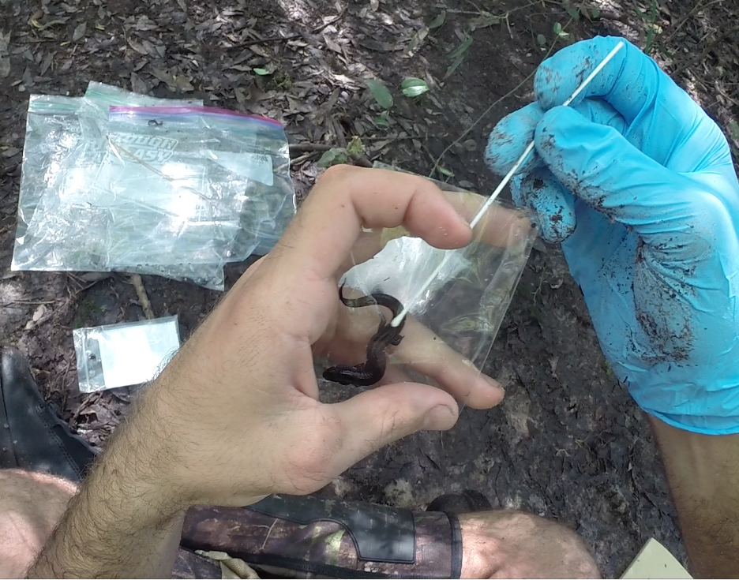
Description: I’m swabbing a Southern Dusky Salamander to test for pathogens (chytrid) before collecting a tissue sample.

